HEART DISEASE PREDICTION USING MACHINE LEARNING

Internship Project Report

Submitted By:
Kummari Anusha

Domain:
Machine Learning & AI

ABSTRACT

Heart disease is one of the leading causes of mortality worldwide, making early diagnosis crucial for improving patient outcomes and reducing healthcare risks. The objective of this project is to develop a machine learning model capable of predicting the likelihood of heart disease using patient medical data.
The project involves data preprocessing, missing value handling, categorical encoding, feature scaling, and classification model development. Logistic Regression and Decision Tree algorithms were implemented and evaluated using various performance metrics including Accuracy, Precision, Recall, F1 Score, Confusion Matrix, and ROC-AUC Curve.
The experimental results demonstrated that Logistic Regression achieved the highest overall performance with an accuracy of 84.24% and an AUC score of 0.91. The developed model can assist healthcare professionals in identifying high-risk patients and supporting timely medical intervention. This project highlights the effectiveness of machine learning techniques in healthcare applications and provides a foundation for future improvements using advanced algorithms and real-time deployment systems.

INDEX

Abstract 2

CHAPTER 1: INTRODUCTION 4
1.1 Background 4
1.2 Problem Statement 4
1.3 Objectives 4
CHAPTER 2: DATASET DESCRIPTION 5
2.1 Dataset Source 5
2.2 Dataset Information 5
2.3 Important Features 5
CHAPTER 3: METHODOLOGY 6
CHAPTER 4: DATA PREPROCESSING 7
CHAPTER 5: EXPLORATORY DATA ANALYSIS 8
CHAPTER 6: MODEL DEVELOPMENT 9
6.1 Logistic Regression 9
6.2 Decision Tree 9
6.3 Train-Test Split 9
CHAPTER 7: RESULTS AND DISCUSSION 10
7.1 Logistic Regression Results 10
7.2 Decision Tree Results 11
CHAPTER 8: MODEL COMPARISON 12
CHAPTER 9: BUSINESS IMPACT 13
CHAPTER 10: CONCLUSION AND FUTURE SCOPE 14
References 15

CHAPTER 1: INTRODUCTION

1.1 Background
Heart disease refers to various conditions that affect the functioning of the heart and blood vessels. It remains one of the most significant health concerns globally and contributes to a large number of deaths each year. Early detection and diagnosis can significantly improve treatment effectiveness and patient survival rates.
Machine Learning has emerged as a powerful technology in healthcare, enabling predictive analysis based on historical patient data. By analyzing patterns within medical records, machine learning models can assist healthcare professionals in identifying patients who are at higher risk of developing heart disease.
1.2 Problem Statement
Heart disease is one of the leading causes of mortality worldwide. Early prediction can significantly improve treatment outcomes and support timely medical intervention. This project aims to develop a machine learning model that predicts the likelihood of heart disease using patient medical data.
1.3 Objectives
- To analyze patient medical data.
- To perform data preprocessing and feature engineering.
- To build classification models for heart disease prediction.
- To evaluate model performance using standard metrics.
- To identify the most suitable model for prediction.

CHAPTER 2: DATASET DESCRIPTION

2.1 Dataset Source
The dataset used in this project is the UCI Heart Disease Dataset.
2.2 Dataset Information
- Total Records: 920
- Total Features: 16
- Target Variable: Heart Disease
2.3 Important Features
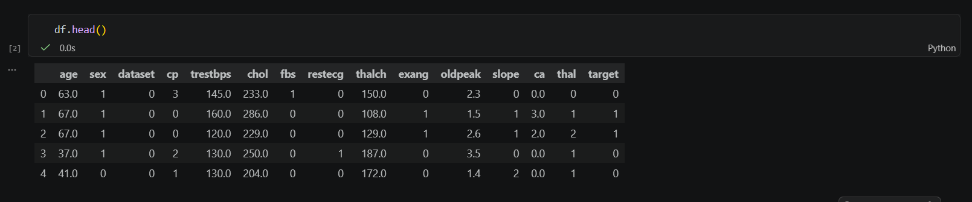
The dataset contains several medical attributes including:
- Age
- Blood Pressure
- Cholesterol
- Chest Pain Type
- Maximum Heart Rate
These features play an important role in determining the likelihood of heart disease in patients.
CHAPTER 3: METHODOLOGY

The project follows a systematic machine learning workflow.

Workflow:
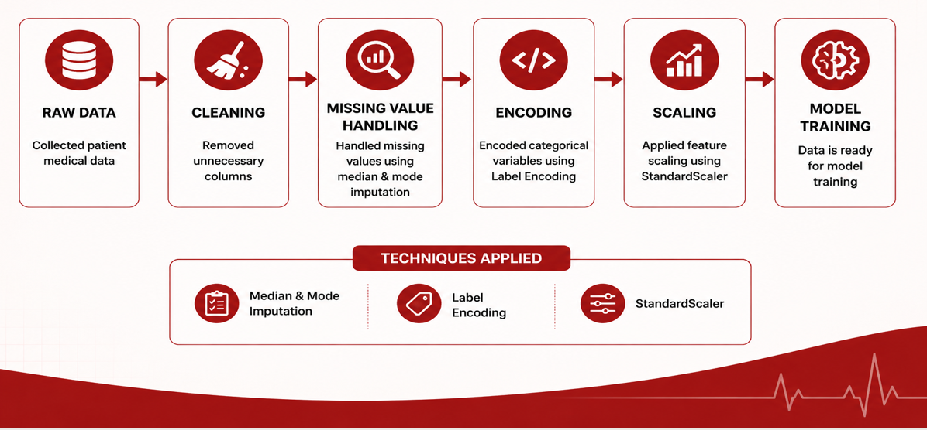

This workflow ensures that the data is prepared appropriately before model development and evaluation.

CHAPTER 4: DATA PREPROCESSING

Data preprocessing is an essential step in machine learning that improves data quality and model performance.
4.1 Missing Value Handling
Missing values were identified and handled using:
- Median Imputation for numerical features
- Mode Imputation for categorical features
4.2 Target Variable Transformation
The target variable was converted into a binary classification problem:
- 0 = No Heart Disease
- 1 = Heart Disease
4.3 Encoding
Categorical features were transformed into numerical format using Label Encoding.
4.4 Feature Scaling
StandardScaler was applied to normalize numerical features and ensure equal contribution during model training.

CHAPTER 5: EXPLORATORY DATA ANALYSIS

Exploratory Data Analysis (EDA) was performed to understand the distribution of features and identify meaningful patterns.
Age Distribution
The analysis showed that a majority of patients belong to middle-age groups. The risk of heart disease generally increases with age.

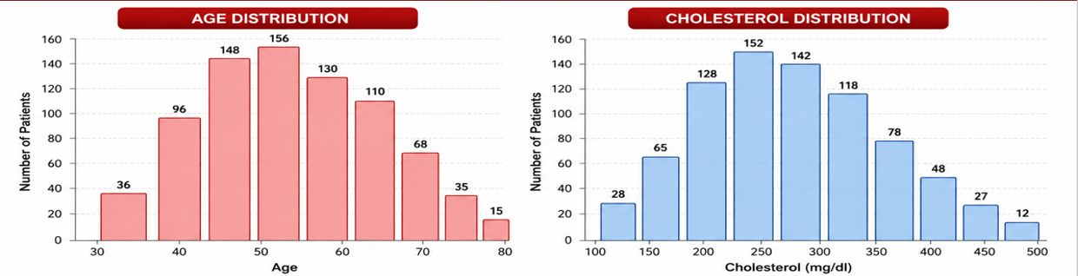

Cholesterol Distribution
Cholesterol values vary significantly among patients. Elevated cholesterol levels are considered an important risk factor for cardiovascular diseases.
Key Insights
- Most patients belong to middle-age categories.
- Cholesterol levels show high variability.
- Heart disease occurrence increases with age.

CHAPTER 6: MODEL DEVELOPMENT

Two machine learning classification models were implemented.
6.1 Logistic Regression
Logistic Regression is a supervised learning algorithm commonly used for binary classification problems. It is simple, interpretable, and computationally efficient.
Advantages
- Easy to understand
- Suitable for binary classification
- Provides probability estimates
6.2 Decision Tree
Decision Tree is a classification algorithm that creates a tree-like structure of decisions based on feature values.
Advantages
- Easy to visualize
- Handles non-linear relationships
- Requires minimal feature engineering
6.3 Train-Test Split
The dataset was divided as follows:
- Training Data: 80%
- Testing Data: 20%
This division helps evaluate model performance on unseen data
CHAPTER 7: RESULTS AND DISCUSSION

7.1 Logistic Regression Results
Metric | Value
Accuracy | 84.24%
Precision | 82.35%
Recall | 86.78%
F1 Score | 84.51%
AUC Score | 0.91
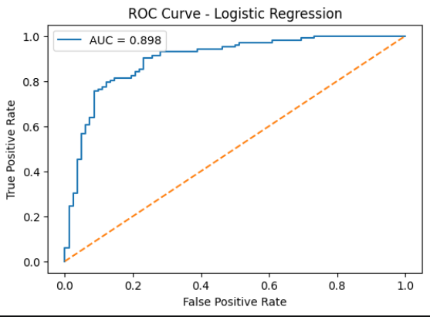
The ROC Curve demonstrated strong classification capability with an AUC score of 0.91, indicating excellent model performance.
7.2 Decision Tree Results
Metric | Value
Accuracy | 82.07%
Precision | 83.50%
Recall | 82.64%
F1 Score | 83.07%
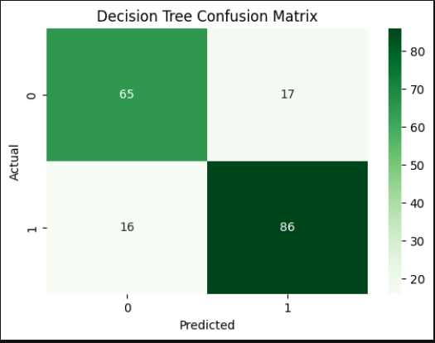
The Decision Tree model achieved satisfactory results and effectively captured feature relationships within the dataset.

CHAPTER 8: MODEL COMPARISON

Model | Accuracy | Precision | Recall | F1 Score
Logistic Regression | 84.24% | 82.35% | 86.78% | 84.51%
Decision Tree | 82.07% | 83.50% | 82.64% | 83.07%

Best Performing Model
Logistic Regression was selected as the best-performing model due to:
- Highest Accuracy
- Highest Recall
- Strong AUC Score (0.91)
- Better Generalization Performance

CHAPTER 9: BUSINESS IMPACT

The developed machine learning model can provide significant benefits in healthcare environments.
Benefits
- Early identification of high-risk patients
- Faster medical screening processes
- Improved clinical decision support
- Better patient outcomes
- Reduced diagnostic delays
The model can serve as a supporting tool for healthcare professionals in making informed decisions.
The proposed solution demonstrates how machine learning can support healthcare professionals by providing faster and more accurate risk assessment for heart disease patients.

CHAPTER 10: CONCLUSION AND FUTURE SCOPE

Conclusion
This project successfully developed a machine learning-based heart disease prediction system using patient medical data. Data preprocessing, feature scaling, and classification techniques were applied to build predictive models. Logistic Regression achieved the best overall performance with an accuracy of 84.24% and an AUC score of 0.91. The results demonstrate the potential of machine learning in supporting early diagnosis and healthcare decision-making.
Future Scope
Future improvements may include:
- Random Forest implementation
- XGBoost implementation
- Deep Learning models
- Real-time hospital integration
- Web and mobile-based prediction systems
These enhancements can further improve prediction accuracy and practical usability.

REFERENCES

[1] UCI Machine Learning Repository. Heart Disease Dataset.
Available: https://archive.ics.uci.edu/
[2] Pedregosa, F., Varoquaux, G., Gramfort, A., et al.
"Scikit-learn: Machine Learning in Python."
Journal of Machine Learning Research, 12, 2825–2830, 2011.
[3] McKinney, W.
"Data Structures for Statistical Computing in Python."
Proceedings of the 9th Python in Science Conference, 2010.
[4] Harris, C. R., Millman, K. J., van der Walt, S. J., et al.
"Array Programming with NumPy."
Nature, 585(7825), 357–362, 2020.
[5] Hunter, J. D.
"Matplotlib: A 2D Graphics Environment."
Computing in Science & Engineering, 9(3), 90–95, 2007.
[6] Géron, A.
Hands-On Machine Learning with Scikit-Learn, Keras, and TensorFlow.
O'Reilly Media, 2019.

